Home Task Lab Manual 6  
Muhammad Azfar Bin Nadeem  
Section C | 459000  
  
Q1) Write a program using break or continue statement that only adds prime numbers from 1 to 50 and display the sum on screen.  
Code  
  
Output  
  
  
Q2) Write a program in C++ to create the following pattern.  
Code  
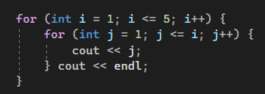  
  
Output  
  
  
  
  
  
  
  
  
Q3) Write a C++ program to print the following.  
Code  
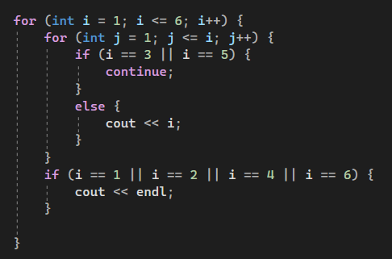  
  
Output  
